Arpeet Nandi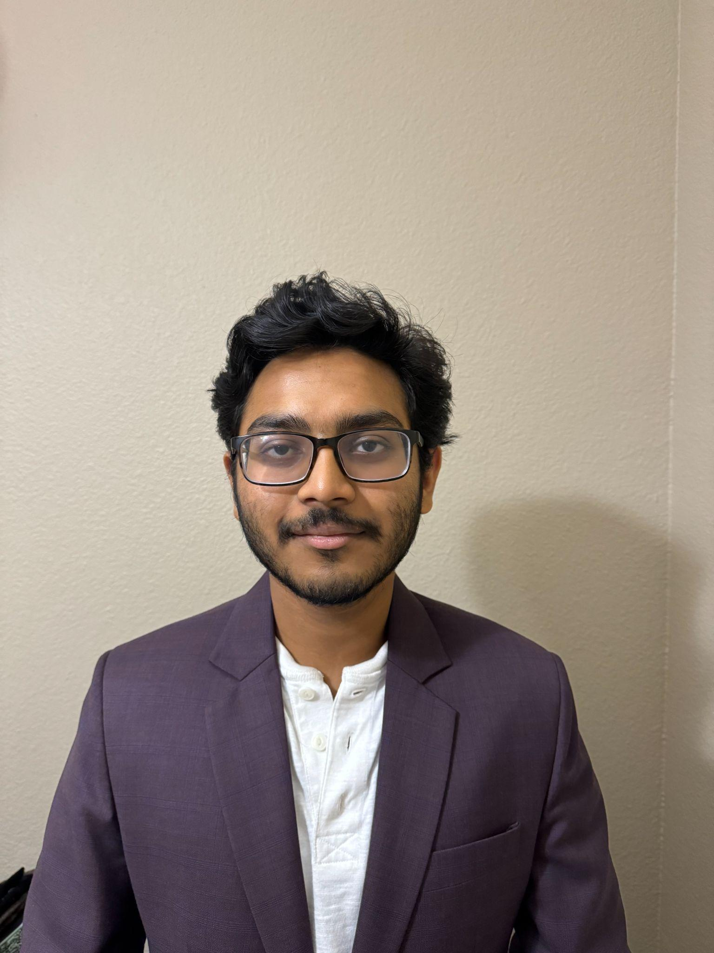

arpeet.nandi@gmail.com

11th grade

UTD

Worked on the story. Created a melee weapon system, health bar and armor system. Added animations too.